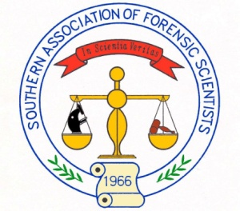
Southern Association of Forensic Scientists
2015 Annual Training Seminar and Symposium
October 12-16, 2015
Georgian Terrace Hotel, Atlanta, GA
Vendor Registration Form (to be sent with payment)
Company Name: _______________________________________________________________________
Address: _____________________________________________________________________________
_____________________________________________________________________________________
Phone: _____________________________ Email: ____________________________________________
Web address: _________________________________________________________________________
Attendee name(s) for Name Tag: __________________________________________________________
Description | Cost | # | Subtotal
Exhibitor Space  (includes space with a 6 foot table with two chairs and 1 banquet ticket) | $1000
Extra dinner Ticket (for additional participants) | $70
Additional Opportunities for Sponsorship
Breaks (morning or afternoon) | $600
Breakfast or Lunch | $900
Other Donation (please describe)

(Contact the SAFS representative below for additional sponsorship opportunities not listed above.)
Total

Please send completed form with remittance made to:
Southern Association of Forensic Scientists
Diana Williams
US Army Criminal Investigation Laboratory
4930 N. 31st St
Forest Park, GA 30297

Additional questions or needs can be sent to:
dianawwilliams@gmail.com or Diana Williams (770)329-1857

